**WORKFORCE DEVELOPMENT PROGRAM ENQUIRY FORM**

Thank you for your interest in the College of the Marshall Islands Workforce Development Program. Please complete the form below to help us understand your needs and provide you with the most accurate information.

**1. Contact Information**

* **Name**: ___________________ **Organization (if applicable)**: _____________________
* **Job Title/Position**: ___________________________
* **Phone Number**: ____________________**Email Address**: ________________________

**2. Sector - Please specify the sector you are requesting services for (check one)**:

Private Public Non-profit

Other (please specify): _____________________________________

**3. Area(s) of Interest -Please select the workforce development area(s) you are interested in (check all that apply)**:

Training and Certification Project Management Development

Soft Skills Strategic Development

Adult Education Leadership Development Compliance & Safety Training

Other (please specify): _____________________________________

**4. Number of Participants -Please specify the number of individuals you want to undertake the Training.**

1-10 11-25 26-50 51-100

More than 100 (please specify): ____________________________

**5. Training Location - Preferred Training Location**:

On-site (at your location) Off-site (provided by our organization)

Virtual/Online Other (please specify): _______________________

**6. Timeframe - When would you like the workforce development program to begin?**

As soon as possible Within 1-3 months Within 6 months

Specific date: ________________________________________

**7. Costing/Budget- Do you have a budget allocated for workforce development?**

Yes No

* **If yes, please provide the estimated budget**: $______________________

**8. Funding Source - Please specify your funding source for the workforce development program**:

Organization/Company Funds Government Grant

Private Sponsor Public Sector Funding

Other (please specify): _____________________________________

**9. Additional Information -Please provide any additional details or specific needs for the workforce development program**:

**10. Submission**

* Please submit your completed form via email to: **(Workforce development email address to be created)**
* Or call us directly for assistance on +6926254803

**Workforce Development Fees**

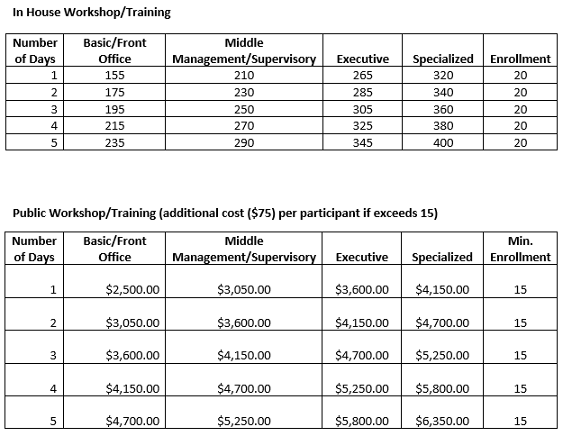

**Thank you for your enquiry!**  
We will review your request and contact you to discuss the next steps.